Sessional No: 08

Problem 1: Graham Scan Algorithm
Logical Solution:
Graham Scan is done by first selecting the pivot which is the point with lowest y-coordinate (If two points have the same y-coordinate, it selects the point with the lowest x-coordinate). Then the remaining points are sorted according to the polar angle with respect to the pivot. Then the pivot and the first element of the sorted list of points are pushed in a stack. Then for the remaining points, if the orientation of that point, the point at the top of the stack and the point at the second top of the stack is clockwise, then the top element of the stack is popped. And after every iteration, the point of the loop is pushed into the stack. Then finally, the points inside the stack are the convex hull points.
Source Code:
#include <bits/stdc++.h>
using namespace std;

pair <int,int> pivot;

bool comp(pair<int,int> p1, pair<int,int> p2) {
float angle1 = atan2(p1.second - pivot.second, p1.first - pivot.first);
float angle2 = atan2(p2.second - pivot.second, p2.first - pivot.first);

if (angle1 == angle2) {
int d1 = (p1.first - pivot.first) * (p1.first - pivot.first) +
(p1.second - pivot.second) * (p1.second - pivot.second);
int d2 = (p2.first - pivot.first) * (p2.first - pivot.first) +
(p2.second - pivot.second) * (p2.second - pivot.second);
return d1 < d2;
}
return angle1 < angle2;
}

int findSide(pair<int,int> p1, pair<int,int> p2, pair<int,int> p) {
int val = (p.second - p1.second) * (p2.first - p1.first) - (p2.second - p1.second) * (p.first - p1.first);
if (val > 0) return 1;
else if (val < 0) return -1;
else return 0;
}

void graham_scan(vector <pair<int,int>> v) {
pivot = {INT_MAX, INT_MAX};
int min = INT_MAX;
for (int i = 0; i < v.size(); i++) {
min = (v[i].second < min) ? v[i].second : min;
}
int index = -1;
for (int i = 0; i < v.size(); i++) {
if (v[i].second == min) {
if (v[i].first < pivot.first) {
pivot = v[i]; index = i;
}
}
}
v.erase(v.begin()+index);
sort(v.begin(), v.end());
v.erase(unique(v.begin(), v.end()), v.end());
sort(v.begin(),v.end(),comp);
stack<pair<int,int>> s;
s.push(pivot);
s.push(v[0]);
v.erase(v.begin());
for (auto &i : v) {
while (s.size() > 1) {
pair<int,int> top = s.top(); s.pop();
pair<int,int> top2 = s.top();
s.push(top);
if (findSide(top2, top, i) > 0) break;
s.pop();
}
s.push(i);
}
cout << endl << "The Convex Hull Points: " << endl;
while (!s.empty()) {
cout << "(" << s.top().first << ", " << s.top().second << ")" << " ";
s.pop();
}
}

int main() {
vector <pair<int,int>> v;
cout << "How many points: ";
int n; cin >> n;
pair <int,int> p;
for (int i = 0; i < n; i++) {
p = make_pair(rand() % 10, rand() % 10);
v.push_back(p);
}
cout << endl << "Generated Points: ";
for (int i = 0; i < n; i++) {
cout << "(" << v[i].first << ", " << v[i].second << ")" << " ";
}
graham_scan(v);
}

Input - Output:
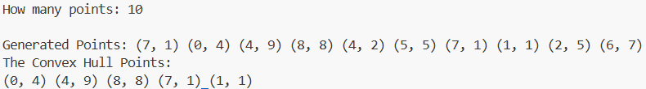
Discussion:
Graham Scan Algorithm is another method to find the convex hull points from a list of points. Quickhull relies on Divide and Conquer method and Graham Scan uses basic Sorting and Stack to find the convex hull. The total complexity of this algorithm is O(nlogn), but the time complexity of Quickhull is O(n^2). Here we can see an improvement in Graham Scan than Quickhull.

Problem 2: Knapsack (Fractional) Problem
Logical Solution:
After taking the corresponding inputs of profits and weights of the objects, we find the objects’ profit / weight ratios. Then we sort the objects in descending order according to this ratio. Then we take the objects one by one according to the p/w ratio and add the profits to a variable and subtract the weights from the Knapsack weight in another variable. We keep doing this until an object comes when subtracting its weight from the remaining Knapsack weight becomes negative. In this case we multiply this object’s p/w with the remaining Knapsack weight and add this to profit, and finally end the loop.
Source Code:
#include <bits/stdc++.h>
using namespace std;

bool comp (tuple<int,int,float> t1, tuple<int,int,float> t2) {
if (get<2>(t1) > get<2>(t2)) return true;
else return false;
}

int main() {
cout << "How many objects: ";
int n; cin >> n;
cout << "Knapsack Weight: ";
int k; cin >> k;
vector <tuple<int,int,float>> v(n);
cout << "Input the corresponding WEIGHTS of the objects:" << endl;
for (int i = 0; i < n; i++) cin >> get<1>(v[i]);
cout << "Input the corresponding PROFITS of the objects:" << endl;
for (int i = 0; i < n; i++) {
cin >> get<0>(v[i]);
get<2>(v[i]) = (float)get<0>(v[i]) / get<1>(v[i]);
}
cout << "Profit / Weight: " << endl;
for (int i = 0; i < n; i++) cout << get<2>(v[i]) << " ";
cout << endl;
sort(v.begin(), v.end(), comp);
float profit = 0; int i = 0;
while (k || (i < n)) {
if ((k - get<1>(v[i])) < 0) {
profit += get<2>(v[i])*k; k = 0;
} else {
profit += get<0>(v[i]);
k -= get<1>(v[i]);
} i++;
}
cout << "Maximum Profit: " << profit << endl;
}
Input - Output:
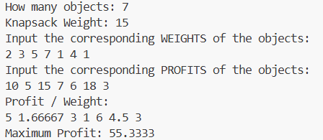

Discussion:
In the Knapsack (Fractional) problem, it can be seen that the Greedy Approach of finding the profit / weight ratio gives us the optimal solution. But in the 0/1 Knapsack problem, it isn’t always the case. It can be a feasible solution but not always the optimal one.

Problem 3: Job Sequencing Problem
Logical Solution:
After taking inputs of the jobs’ profits and deadlines, we sort them in descending order according to their profits. Then we select the jobs sequentially from the sorted list and place the job selected to the last possible slot available according to their deadline. If a job’s deadline slot is occupied by another job, we check the previous slot. Like this, the algorithm will keep checking until the first slot. In this way, when all the slots fill up, the algorithm ends.
Source Code:
#include <bits/stdc++.h>
using namespace std;

// profit, deadline, number
bool comp (tuple<int,int,int> p1, tuple<int,int,int> p2) {
if (get<0>(p1) > get<0>(p2)) return true;
else return false;
}

int main() {
cout << "How many jobs: ";
int n; cin >> n;
vector <tuple<int,int,int>> v(n);
for (int i = 0; i < n; i++) get<2>(v[i]) = i+1;
cout << "Input the corresponding DEADLINES of the jobs:" << endl;
for (int i = 0; i < n; i++) cin >> get<1>(v[i]);
cout << "Input the corresponding PROFITS of the jobs:" << endl;
for (int i = 0; i < n; i++) cin >> get<0>(v[i]);
sort(v.begin(), v.end(), comp);
int max_deadline = -1;
for (int i = 0; i < n; i++) {
max_deadline = (get<1>(v[i]) > max_deadline) ? get<1>(v[i]) : max_deadline;
}
vector <tuple<int,int,int>> slots(max_deadline);
for (int i = 0; i < n; i++) {
for (int j = get<1>(v[i])-1; j >= 0; j--) {
if (get<0>(slots[j]) == 0 && get<1>(slots[j]) == 0) {
slots[j] = v[i];
break;
}
}
}
cout << endl << "Doable Jobs: " << endl;
int profit = 0;
for (int i = 0; i < max_deadline; i++) {
cout << "Slot " << i+1 << ": " << "Job " << get<2>(slots[i]) << endl;
profit += get<0>(slots[i]);
}
cout << "Maximum Profit:" << " " << profit << endl;
}
Input - Output:
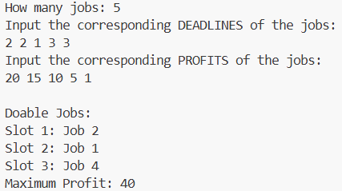
Discussion:
This solution of the Job Sequencing problem also uses a Greedy Approach like the previous Knapsack problem. It is being greedy based solely on profits of the jobs. It does not consider any other parameters like the deadlines of the jobs. It just tries to maximize the profit by taking the job with the maximum profit available. It keeps doing it until there are no slots left.
Problem 4: Coin Change Problem
Logical Solution:
The Coin Change problem is also solvable with a Greedy approach. Here, the algorithm checks the largest coin which is less than the given amount. It tries to take that amount as long as it is possible. When the amount becomes less than this coin, it moves to the next smaller coin and checks with it again. It keeps doing this process until the amount can be expressed with the least amount of coins.
Source Code:
#include <bits/stdc++.h>
using namespace std;

bool comp (pair<int,int> p1, pair<int,int> p2) {
if (p1.first > p2.first) return true;
else return false;
}

int main() {
cout << "Enter the amount (<=100): ";
int a; cin >> a;
int coins[] = {1, 2, 5, 10, 20, 50, 100};
int num[] = {0,0,0,0,0,0,0};
int i = 6;
while (a) {
if ((a - coins[i]) < 0) i--;
else {
a -= coins[i];
num[i]++;
}
}
cout << "Number of coins needed: " << endl;
for (int i = 0; i < 7; i++) {
cout << "Coin " << coins[i] << ": " << num[i] << endl;
}
}

Input - Output:
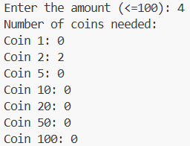
Discussion:
The Coin Change problem is solvable with a greedy approach. But in this problem, the coins are already given and with these coins any amount can be expressed optimally with this algorithm. But if any of these coins were not available, this approach might not give the optimal solution.

